2019 East Kootenay FIDS Permanent Sample Plot Results

Background
In 2007 thirteen PSP’s formerly monitored by the Forest Insect and Disease Survey Unit of Forestry Canada were re-established in the East Kootenays to monitor the incidence of western false hemlock looper, Nepytia freemani and western spruce budworm, Choristoneura occidentalis (Figure 1). The East Kootenays do not have history of visible defoliation by western spruce budworm. It is possible however, that given climate change and Douglas-fir encroachment throughout the Rocky Mountain Trench, that conditions may become favorable to the expansion of western spruce budworm populations either from the west, or from the south. PSS 15, 19, 21, 37, 39, and 42 are all in the Cranbrook TSA, while PSS 48, 50, 51, 52, 55, 57, and 66 are in the Invermere TSA.

Results
Western spruce budworm populations continue to remain low with only 1 positive site, containing 1 larva near Edgewater (Table 1). Conifer sawflies were the most common defoliator noted, found at 8 of 13 sites, followed by false hemlock looper and green striped forest looper both found at 5 sites. Defoliator diversity was down to 7 from 10 defoliator species recorded in 2018 (Table 1).
Table 1. Insect counts from three-tree beatings conducted in the East Kootenays, in 2019.
PSS | Date | Location | Choristoneura occidentalis | Lambinda f lugubrosa | Nepytia freemani | Melanolophia imitata | Cosmia praeacuta | Nematocampa resistaria | Anoploynx spp | Egira hiemalis | Dichelonyx backi | Neodiprion | Eupithecia annulata | Noctuidae | Defoliation
15 | 29-Jun-19 | Matthews FSR |  |  |  |  |  |  |  |  |  | 1 |  | 1 | Nil
19 | 29-Jun-19 | Grasmere Dorr Road | 0 |  |  |  |  |  |  |  |  |  |  |  | Nil
21 | 29-Jun-19 | Elko area | 0 |  |  |  |  |  |  |  |  |  |  |  | Nil
37 | 29-Jun-19 | Norbury Lakes Provincial Park | 0 |  |  |  |  |  |  |  |  |  |  |  | Nil
39 | 29-Jun-19 | Wildhorse River FSR |  |  |  | 1 |  |  |  |  |  | 1 |  |  | Nil
42 | 29-Jun-19 | Wasa Sheep Crk Rd |  |  |  | 2 |  |  |  |  |  | 1 |  |  | Nil
48 | 29-Jun-19 | Findlay Crk Road |  |  |  |  |  |  |  |  |  | 2 |  |  | Nil
50 | 29-Jun-19 | Dutch Creek |  |  | 1 |  |  |  |  |  |  |  |  |  | Nil
51 | 29-Jun-19 | Mt. Swansea Trailhead |  |  | 4 |  |  |  |  |  |  | 2 |  |  | Nil
52 | 28-Jun-19 | Lillian Lake Rec Site |  |  |  |  |  |  |  |  | 2 |  |  |  | Nil
55 | 28-Jun-19 | Horsetheif FSR |  | 1 |  | 1
57 | 28-Jun-19 | Edgewater S Rd | 1 |  |  | 1 |  |  |  |  |  |  |  |  | Nil
66 | 28-Jun-19 | Hwy 1 W of Golden |  |  |  |  |  |  |  |  |  | 1 |  |  | Nil
 |  | TOTAL | 1 | 1 | 5 | 5 | 0 | 0 | 0 | 0 | 2 | 8 | 0 | 1 | 23

V
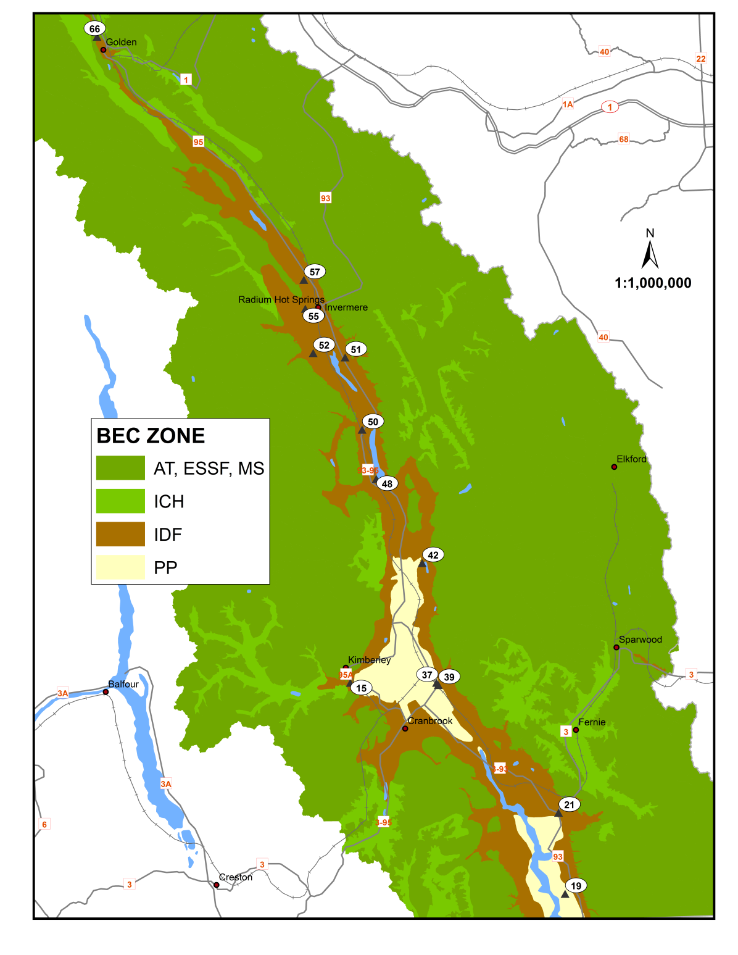
Figure 1. Plot distribution in the Rocky Mountain Trench.

Other Noteworthy Pests
Ongoing drought damage e.g. flagging, whole tree mortality, to young Douglas-fir was evident throughout the study area particularly in stands which had undergone ecosystem restoration work, and lodgepole pine stands near Kimberley, west of Marysville, on dry knolls in the Salmo-Creston pass, and in the Boundary area. Similar to previous years serpentine leaf miner was ubiquitous throughout the host range. Moderate to severe birch leaf miner was noted intermittently in west of Golden (Figure 2), and the Salmo-Creston pass, with most severe areas noted on the west side of the pass. Spruce mortality was also noted in the wetlands between Wilmer and Radium Hot Springs on Westside road (Figure 3).
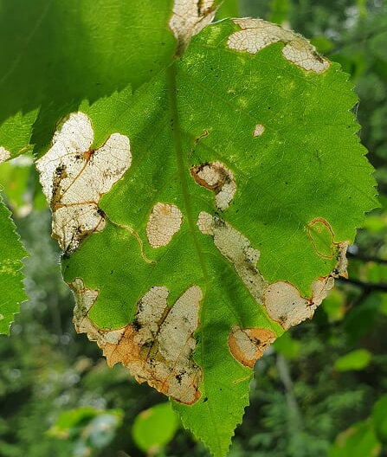
Figure 2. Birch leaf miner damage west of Golden.
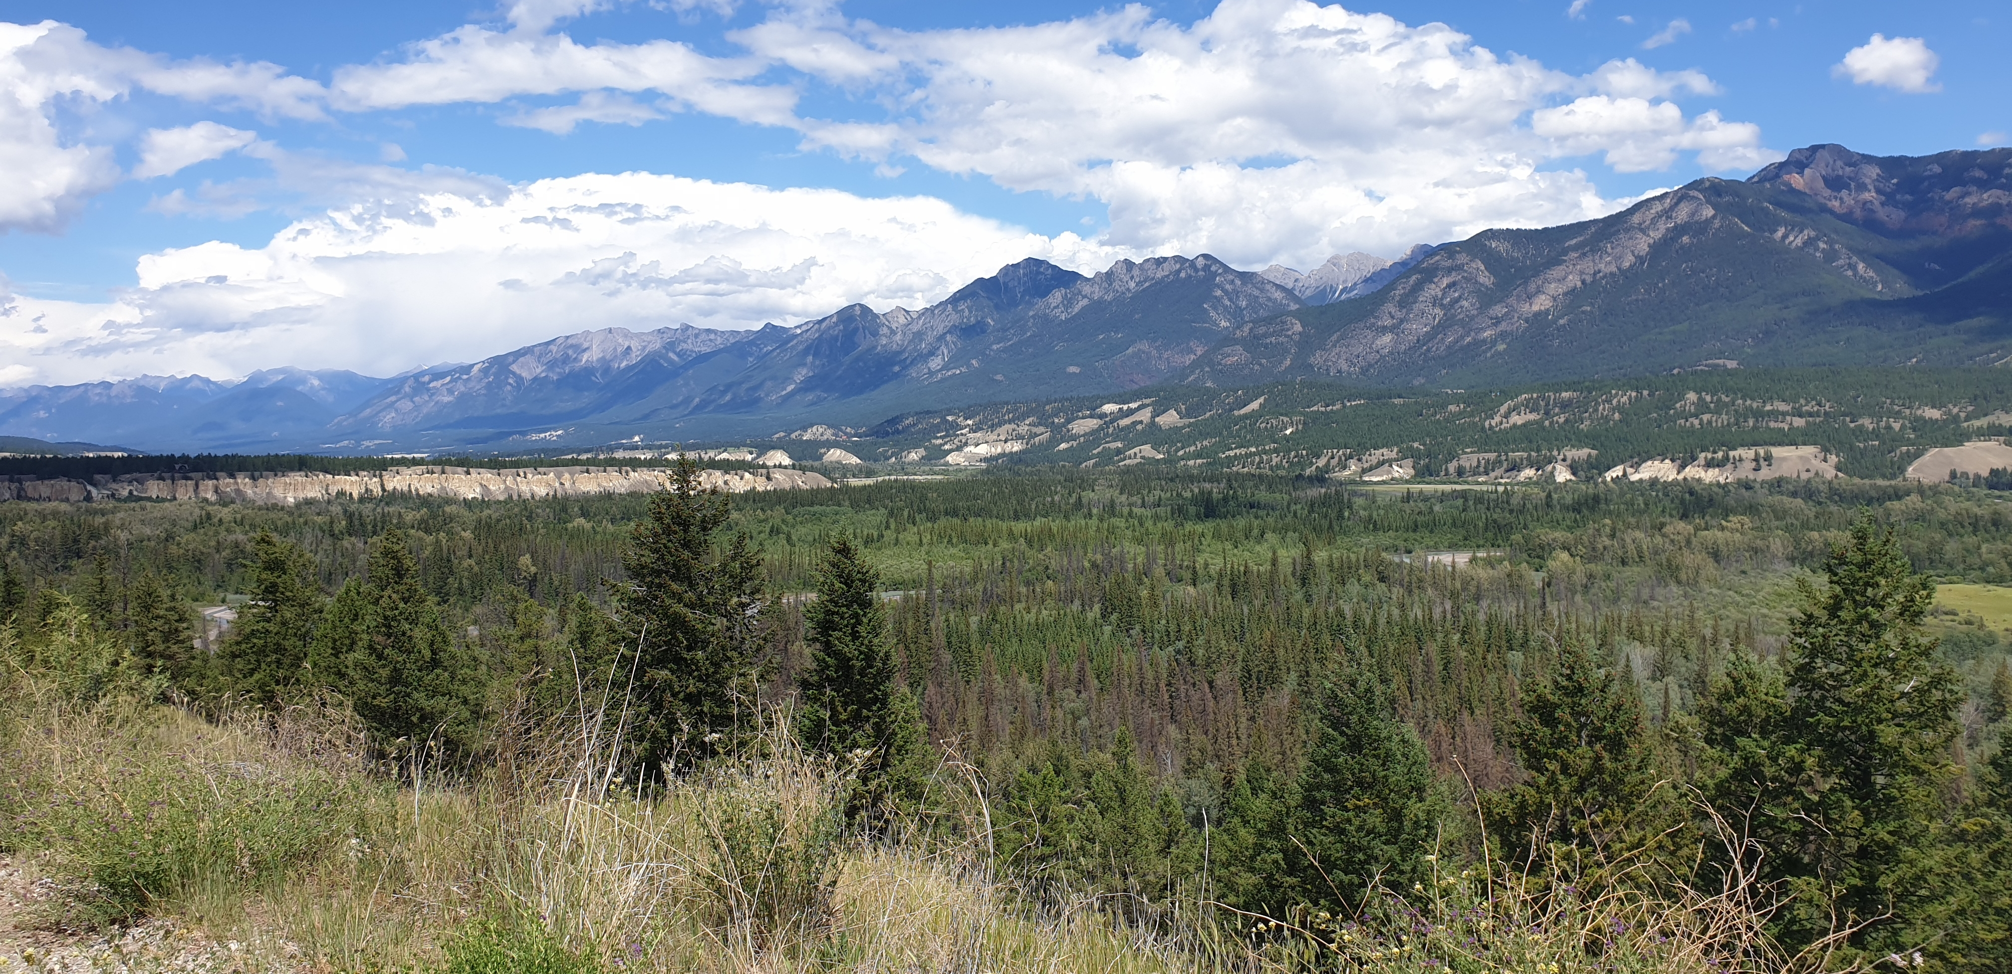
Figure 3. Dead and dying spruce in wetlands in Rocky Mountain Trench between Wilmer and Radium Hot Springs.

